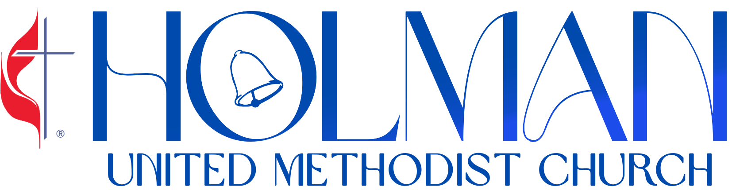 The Church of the Bells | July 19, 2026  8th Sunday After Pentecost  11:00 am · www.holmanumc.com


CENTERING MOMENT
Breathe in and consider what God has done throughout the generations.
Breathe out in hope and gratitude for what God will do in worship today.

PRELUDE |  |  |  | “Still I Rise”  Percy Brady, Yolanda Adams |  |  |  |  | Robert Johnson, Jr.
OPENING SONG |  |  |  | “Let It Rise”  Holland Davis |  |  |  |  | Jubilant Voices
WELCOME |  |  |  |  |  |  |  |  | Rev. Victor Cyrus-Franklin  Lead Pastor
GREETING |  |  |  |  |  |  |  |  | Nancy Harris  Liturgist
*CALL TO WORSHIP
There is nowhere we can flee from God’s presence.
In the heavens and in the depths, the Holy One abides with us.
We are God’s children, serving the Lord from generation to generation.
God is the one who keeps promises and who provides for us wherever we go.
How awesome is this place!
This is God’s house and we have come to worship the living God.

*OPENING PRAYER
Source of vision and hope, we find renewal as we worship you.
Helps us remember our connection with you,
as generations before us did and generations will to come.
Come into this space and enliven our hearts.
We welcome your Spirit to guide us to where we should go
and for Jesus to lead us in who we should be! Amen!

OPENING HYMN |  |  |  | “We Are Climbing Jacob’s Ladder” |  |  |  | Hymnal #418
*PASSING OF THE PEACE |  |  |  | “If You’re Happy”  Wilbert Baltimore |  |  |  | Jubilant Voices
Greet one another with signs of God’s peace and love! Be sure to ask your neighbor if it’s okay to hug them!

*SCRIPTURE |  |  |  | Romans 6:1-5  Common English Bible (CEB) |  |  |  | Nancy Harris  Liturgist

SONG OF PREPARATION |  |  |  | “Stand Up”  Joshua Campbell |  |  |  |  | Jubilant Voices  Soloist: Melida Skeete Smith
MESSAGE |  |  |  | “And Still We Rise” |  |  |  |  | Rev. Victor Cyrus-Franklin  Lead Pastor
INVITATIONAL HYMN |  |  |  | “My Life Is In Your Hands"  Kirk Franklin |  |  |  |  | Jubilant Voices
PRAYER FOR THE PEOPLE |  |  |  |  |  |  |  |  | Rev. Louis Chase  Associate Pastor
STEWARDSHIP MOMENT

THANKSGIVING FOR  TITHES & OFFERING |  |  |  |  | “Oh Give Thanks”  Judith Christie McAllister |  |  | Jubilant Voices
*DOXOLOGY |  |  |  |  | “Praise God From Whom All Blessings Flow” |  |  | Hymnal #95
ANNOUNCEMENTS

*BENEDICTION |  |  |  |  | “I Feel Like Going On”  Marvin Winans |  |  | Jubilant Voices
POSTLUDE |  |  |  |  | “Risin’ To The Top”  Keni Burke, Norma J. Wright, Allan W. Felder |  |  | Robert Johnson, Jr.

TODAY IN WORSHIP

Rev. Victor Cyrus-Franklin, Lead Pastor, Rev. Louis Chase, Minister of Community Outreach; Nancy Harris, Liturgist; Melida Smith, Jubilant Voices Director; Robert Johnson, Jr., Assistant Director of Music; Ricardo Mowatt, Drummer; David R. Sears, Production Mixer; Mark Conway, Video Director; Keith McGruder, House Mixer; Fitzroy Younge, House Mixer; Jules Green, Post-Production; Mychael Carter, Audio Tech/Mixer.

WAYS TO GIVE
- Mail: Send to Holman UMC,  3320 W Adams Blvd., Los Angeles, CA 90018  - Radio Broadcast Sponsorship:  Complete form at holmanumc.com/forms |   - Online: Go to the church website @ www.holmanumc.com/give  - Altar Flowers Sponsorship:  Visit holmanumc.com/forms and look under ‘Special Donations.’

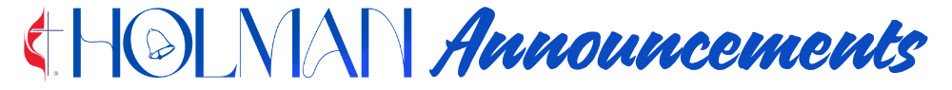

Please submit announcement requests to the church office by Wednesday at 12 noon.

ALTAR FLOWERS & RADIO BROADCAST SPONSORSHIP

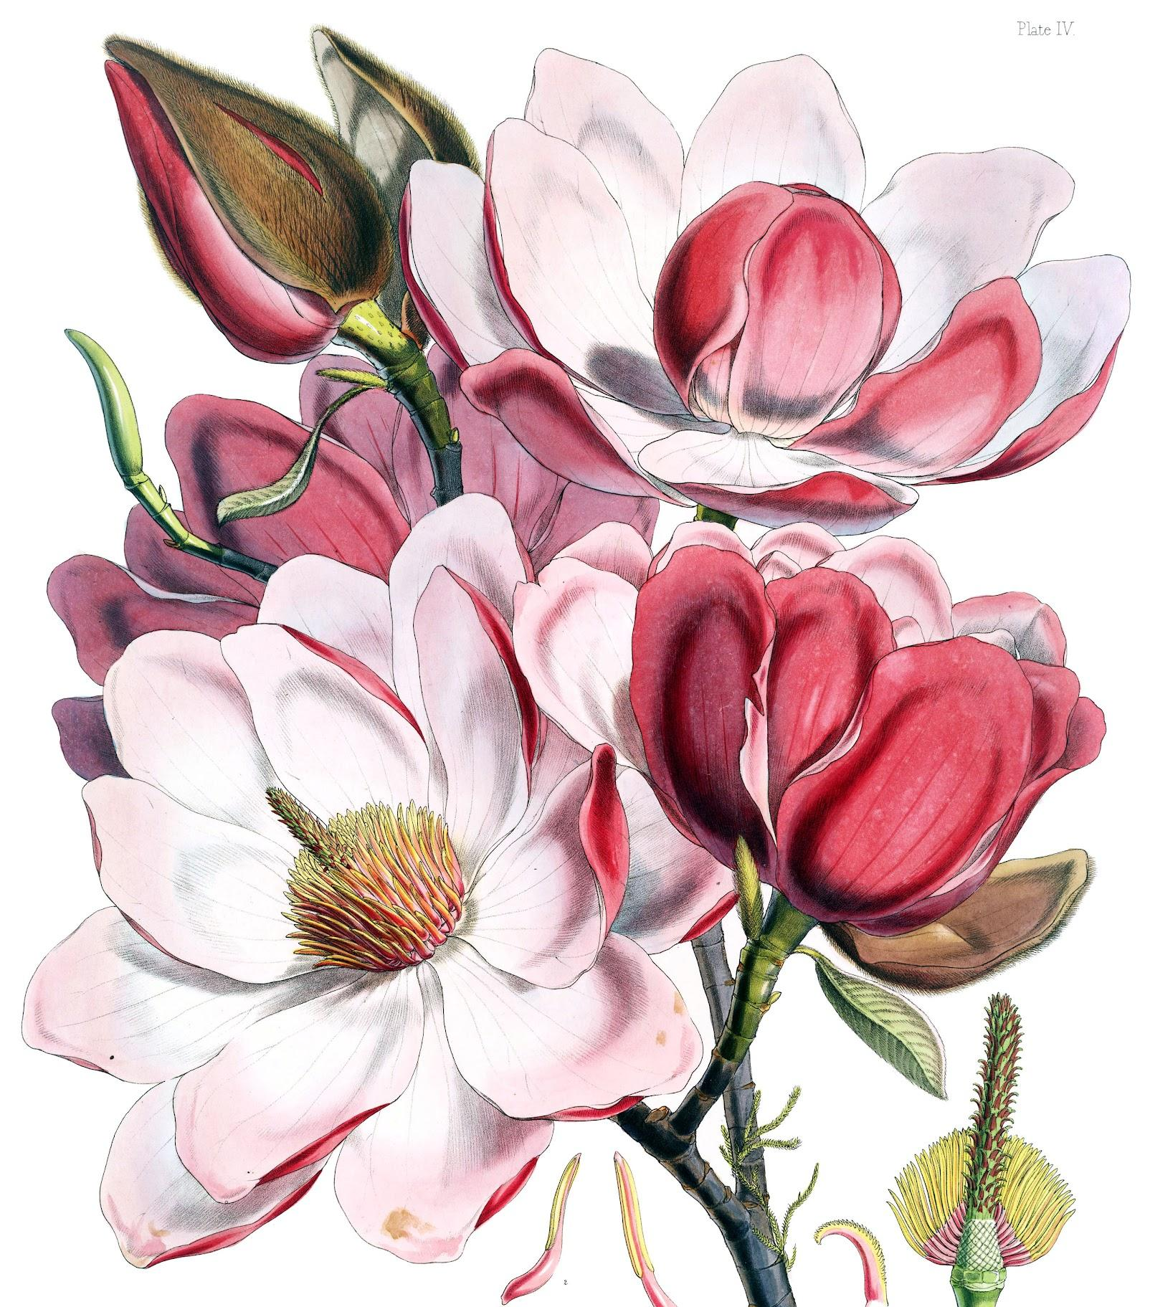
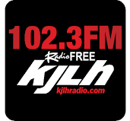
Today’s altar flowers are sponsored by Brenda Shockley for Beverly Davis, in honor of her birthday. Thank you for over 6 years of friendship!

You can sponsor our live broadcast on Radio Free KJLH, 102.3 FM, or adorn the sanctuary with an arrangement of altar flowers. Visit holmanumc.com/forms or call the church office.

AFTER WORSHIP

Join us for the Fellowship Hour in the L. L. White Hall, immediately following the worship service hosted by the Hospitality Committee. Today is the United Women in Faith: Spiritual Growth Circle hosted in the library after worship!

NEXT SUNDAYJoin us for Sunday Worship next week for service as Rev. Dr. Jennifer Oliver gives the message. The Jubilant Voices will lead us in music.

CONGREGATIONAL CARE
BEREAVEMENT | Holman member Gilbert Jones passed away on July 9 and his Celebration of Life will be on July 29 at 11:00 am at Holman. Meah Simone Bordenave-Jenkins, granddaughter of Holman member Delores Jenkins passed away July 4. Service arrangements are on July 30. The Celebration of Life for Holman Member Dorothy Thomas is on Friday, July 31 at 11:00 am. Holman member Hal Williams passed away last week and arrangements are pending. Terell Farris, nephew of Holman member Julia Jackson. Celebration of Life service will be held in Las Vegas, August 1

The homegoing service for Jeffrey Stephens, son of Mrs. Joyce Stephens and brother of Ms. Vicki Stephens Allen was held July 15 at Inglewood Mortuary. The homegoing service for Emma Bell Cross, sister of Holman member Geraldine Jordan was held on July 11.

Let us continue to hold our bereaved families in prayer.

PRAYER LIST | Service people being sent to war in Iran and around the world. Barbara Rosenbaum, Apryl Hall, Audrae Broadnaux, Barbara Williams, Brenda Martin, Carolyn Moultrie, Deidra Gray, Eretha Minor, Frances Grady, Freddie Muse, Jr., Garth Morgan, Gilbert Jones, Gloria Smith, Gweneth Alexander, Irving Norwood, Sr., Jason Rabb, Jo C. Reed, Joyce Lewis, Juanita Cannon, Kamille Linton, Larry Johnson, Larry Turner, Maritza Brown, Meredith Barrett, Ovis Massey, Paul Madison, Phyllis Stephenson, Sylvia Carter, Dr. Zan Holmes, Rob Durden, Ruth A. Smith, Staci Williams, Ted Davis, Toni Edwards, Walter Fletcher, Dr. Quinton James, Dr. Ronald St. Hill, Edwena Weathersby & The Wiley Family, The Batiste Family, The Cincore Family, The Douglas Family, The Henley Family, The Hobson Family, The Luke Family, The Newsom Family, The Spearman Family.


www.holmanumc.com/calendar

SUNDAY, JUL 19  Holman Choir: Rehearsal  9–10:30am | Every Sunday  Holman UMC Music Room  Book Talk: Zoom  9:15–10:15am | Every Sunday  Adult Sunday School: Class  9:30–10:30am | Every Sunday  Online  Children's Church/Sunday School: Gathering  9:30–10:30am | Every Sunday  Holman Education Building - Room 7  United Women in Faith: Spiritual Growth Circle  1–3pm | The third Sunday of every other month  Holman UMC  TUESDAY, JUL 21  Trustees: Monthly Meeting  6:30–7:45pm | The third Tuesday of every month  Online  WEDNESDAY, JUL 22  Prayer Shawl Ministry  12–2pm | The 2nd and 4th Wednesday of every month  Holman UMC  THURSDAY, JUL 23  Hearing to Close the Murphy Drill Site  10–11:30am  Online  StoreHouse Ministry Food Distribution Day  10am–1pm | The 2nd and 4th Thursday of every month  Holman UMC  Thursday Bible Study: (Phone)  1–2pm | Every Thursday  FRIDAY, JUL 24  Friday Morning Prayer Group: Prayer & Communion Service (Phone)  7–8am | Every Friday | Mark Your Calendars!  SUNDAY, JUL 26  Holman Choir: Rehearsal  9–10:30am | Every Sunday  Holman UMC Music Room  Book Talk: Zoom  9:15–10:15am | Every Sunday  Online  Adult Sunday School: Class  9:30–10:30am | Every Sunday  Online  Children's Church/Sunday School: Gathering  9:30–10:30am | Every Sunday  Holman Education Building - Room 7  Pastors' Bible Study: Sunday Morning  9:30–10:30am | The 2nd and 4th Sunday of every month  Holman UMC / Crockett Library  TUESDAY, JUL 28  Finance Committee: Monthly Meeting  6:30–7:45pm | The fourth Tuesday of every month  Online  WEDNESDAY, JUL 29  Celebration of Life - Gilbert Jones  11am–1:30pm  THURSDAY, JUL 30  Thursday Bible Study: (Phone)  1–2pm | Every Thursday  Celebration of Life - Meah Bordenave-Jenkins  FRIDAY, JUL 31  Friday Morning Prayer Group: Prayer & Communion Service (Phone)  7–8am | Every Friday  Celebration of Life - Dorothy Thomas  11am–1:30pm

