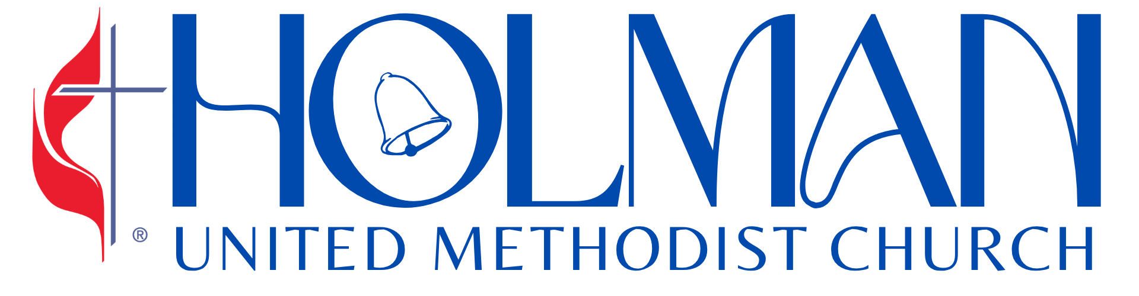 The Church of the Bells | September 27, 2026  18th Sunday after Pentecost  11:00 am · www.holmanumc.com


CENTERING MOMENT
Let the same mind be in you that was in Christ Jesus

PRELUDE |  |  |  | “Dear Lord, Forgive”  C. Maud Battersby, Charles Gabriel |  |  |  |  | Robert Johnson, Jr.
WELCOME |  |  |  |  |  |  |  |  | Rev. Dr. Jennifer Oliver  Lead Pastor
OPENING SONG |  |  |  | “Trading My Sorrows”  Israel Houghton |  |  |  |  | Jubilant Voices
GREETING |  |  |  |  |  |  |  |  | Rose Whitehead  Liturgist
*CALL TO WORSHIP
Let the same mind be in you that was in Christ Jesus. “What is the mind of Jesus?”
The mind of Jesus is to love God, neighbor, self, and all creation
Paul reminds us that “it is God who is at work in you.” How is God at work in us?
God enables us through grace to love God, neighbor, self, and all creation
Paul exhorts us to “work on your own salvation with fear and trembling.” How do we work on our salvation?
We cooperate with grace to love God, neighbor, self, and all creation.
We gather to worship God who, through Jesus, shows us how to love and enables us to love as Christ loves us
We gather to learn how to live in full accord through our love of God, neighbor, self, and all creation

*OPENING PRAYER
Gracious and loving God,
Open our hearts to hear your voice and give us courage to respond with faithful action. By your grace, shape us in the mind of Christ, that what we way and how we live may reflect your love. Amen.

OPENING HYMN |  |  |  | “Glory, Glory Hallelujah”  Spiritual |  |  |  | Hymnal #500
*PASSING OF THE PEACE |  |  |  | “Holman Is a Place (Welcome To The Village)”  Leon Lewis |  |  |  | Jubilant Voices
Greet one another with signs of God’s peace and love! Be sure to ask your neighbor if it’s okay to hug them!
*SCRIPTURE |  |  |  | Matthew 21:23-32  Common English Bible (CEB) |  |  |  | Rose Whitehead  Liturgist

SONG OF PREPARATION |  |  |  | “Second Chance”  Hezkiah Walker |  |  |  |  | Jubilant Voices
MESSAGE |  |  |  | “God of a Second Chance” |  |  |  |  | Rev. Dr. Jennifer Oliver  Associate Pastor
INVITATIONAL HYMN |  |  |  | “Release Your Power”  David Willerdorf |  |  |  |  | Jubilant Voices
PRAYER FOR THE PEOPLE |  |  |  |  |  |  |  |  | Rev. Louis Chase  Minister of Community Outreach

THANKSGIVING FOR  TITHES & OFFERING |  |  |  |  | “Bless The Lord With Me"  Arzella Baker |  |  | Jubilant Voices
*DOXOLOGY |  |  |  |  | “Praise God From Whom All Blessings Flow” |  |  | Hymnal #95
ANNOUNCEMENTS
*BENEDICTION |  |  |  |  | “Thank You Lord”  Stephen Key |  |  | Jubilant Voices
POSTLUDE |  |  |  |  | “The Second Time Around”  William Shelby, Leon Sylvers |  |  | Robert Johnson, Jr.

TODAY IN WORSHIP

Rev. Dr. Jennifer Oliver, Associate Pastor, Rev. Louis Chase, Minister of Community Outreach; Rose Whitehead, Liturgist; Melida Smith, Jubilant Voices Director, Robert Johnson Jr.; Assistant Director of Music, Mark Conway, Video Director; Keith McGruder, House Mixer; Fitzroy Younge, House Mixer; Jules Green, Post-Production; Mychael Carter, Audio Tech/Mixer.

WAYS TO GIVE

- Mail: Send to Holman UMC,  3320 W Adams Blvd., Los Angeles, CA 90018  - Radio Broadcast Sponsorship:  Complete form at holmanumc.com/forms | 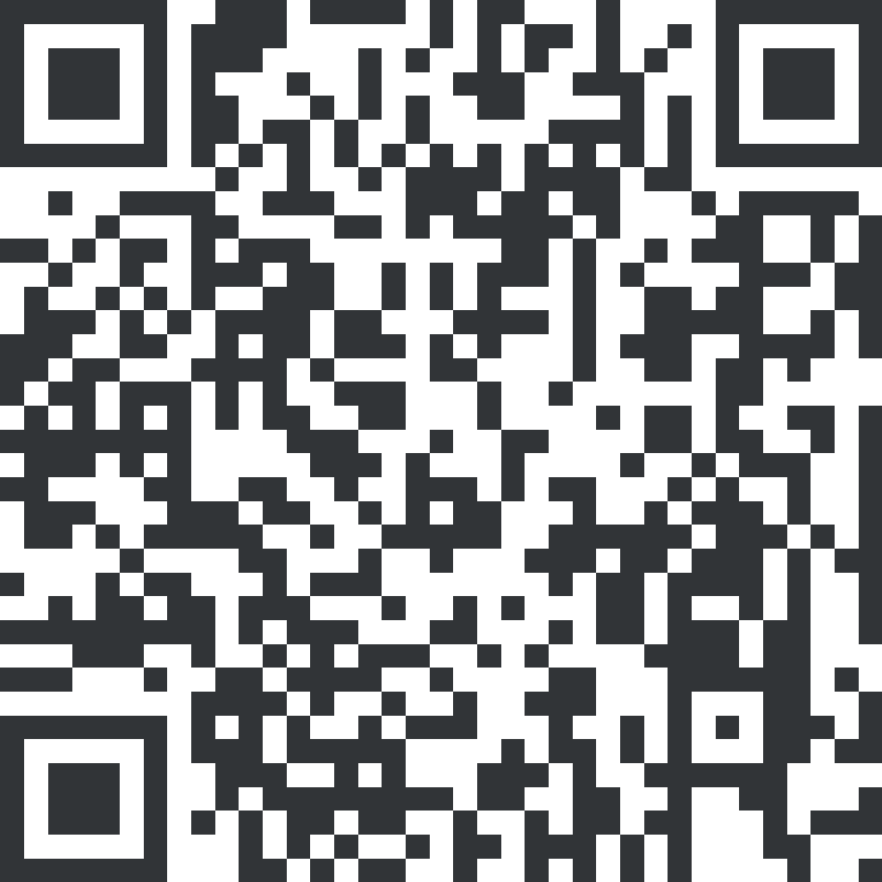  - Online: Go to the church website @ www.holmanumc.com/give  - Altar Flowers Sponsorship:  Visit holmanumc.com/forms and look under ‘Special Donations.’

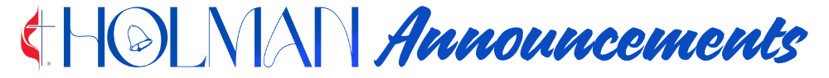

Please submit announcement requests to the church office by Wednesday at 12 noon.

ALTAR FLOWERS & RADIO BROADCAST SPONSORSHIP

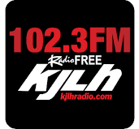
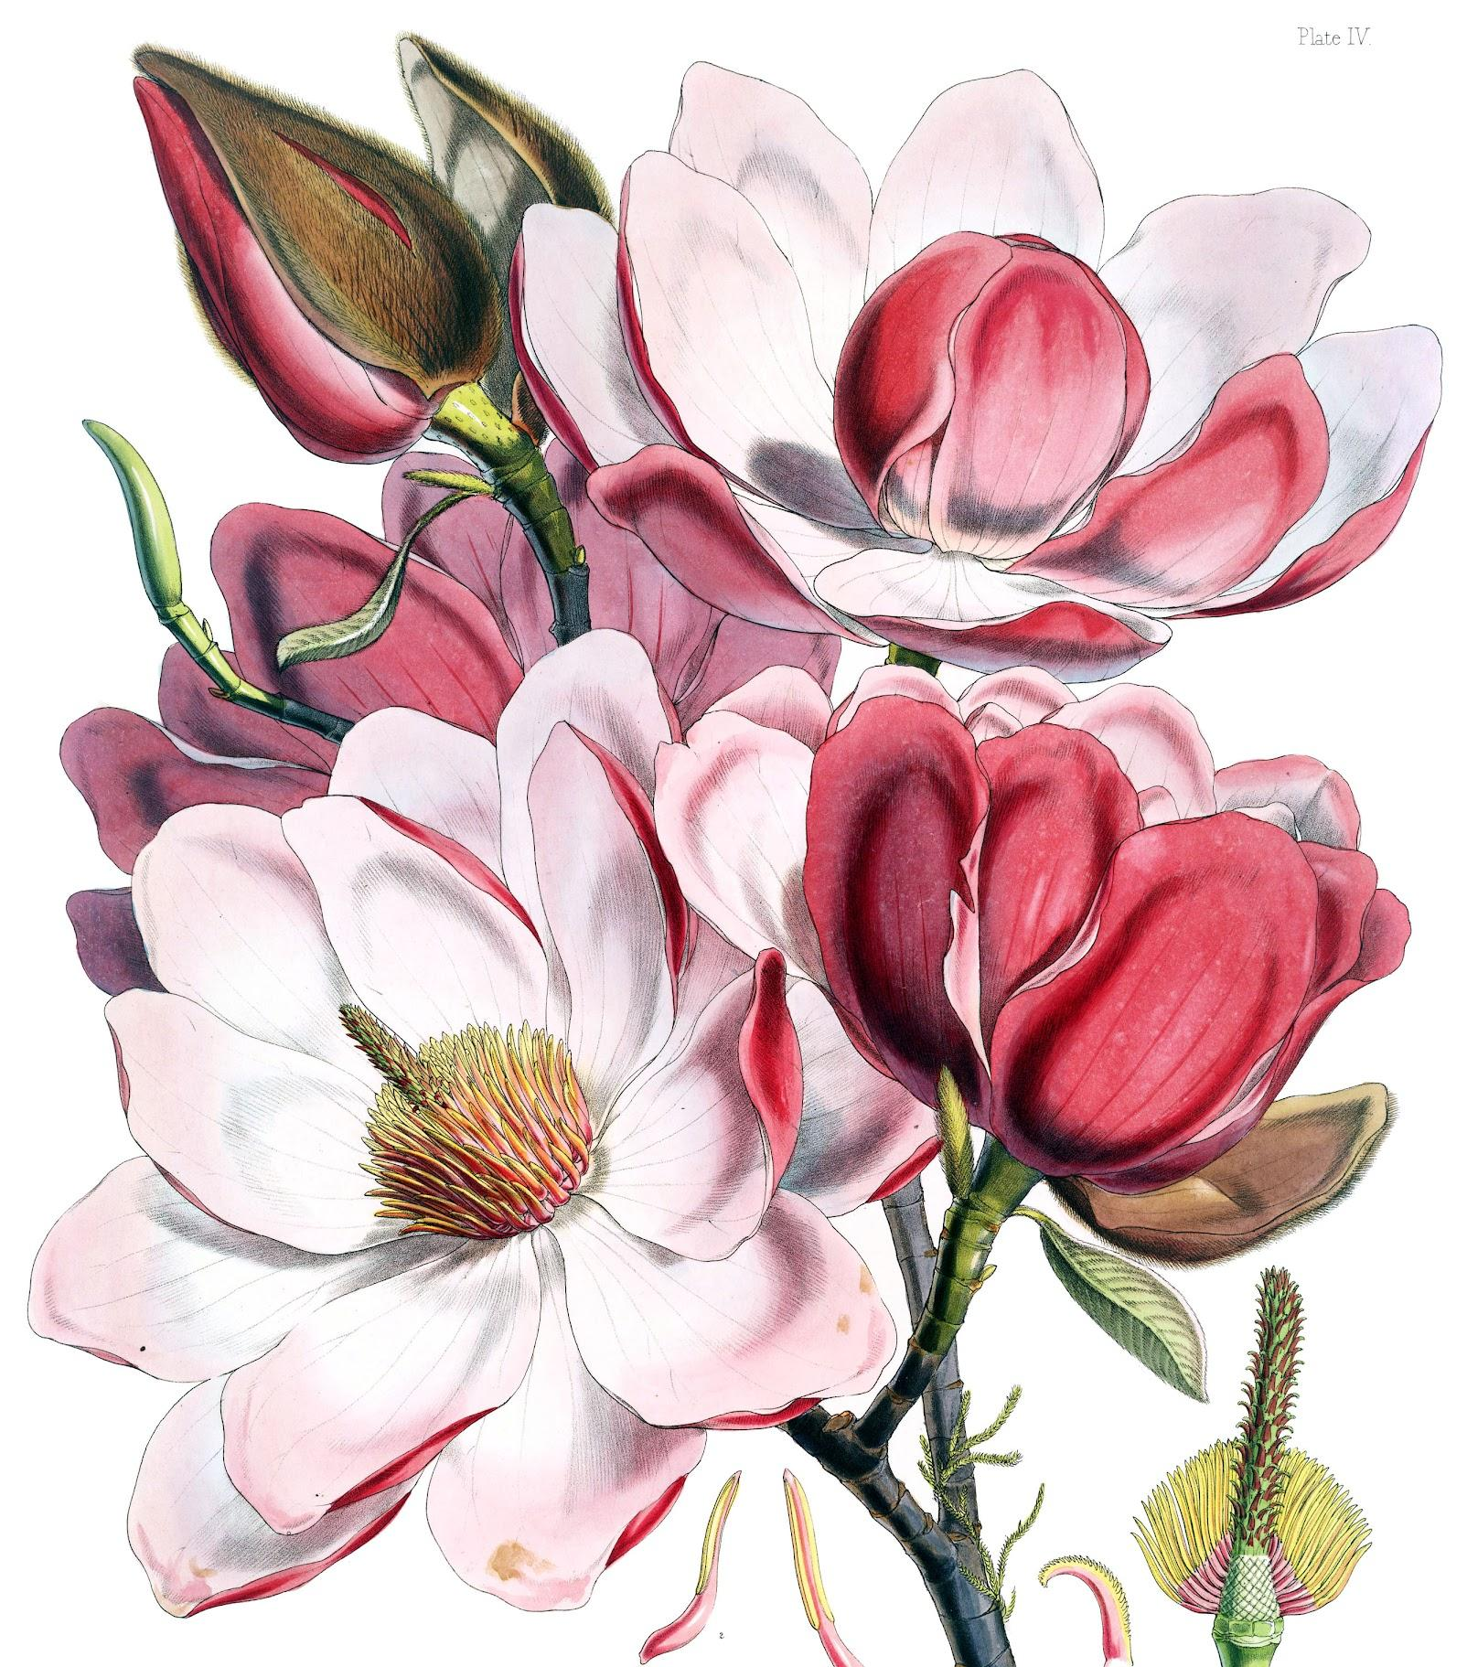
Today's altar flowers are sponsored by Sylvia Swilley, In memory of Mary Johnson, my favorite pew pal. I will always cherish our short time in the course of your long life.

The altar flowers are given in celebration of Deborah A. Mitchell on the book signing of her book. May the prayers within its pages remind every reader that they can come to our Heavenly Father just as they are and find Him ready to listen. From the Nurture Ministries and the Jubilant Voices.

Today’s altar flowers are also sponsored by Michelle and Nicholas Blackburn, in honor and love of their
mother and grandmother, Mrs. Barbara Carr, for her September 30, 2026 birthday. We thank GOD for her love, kindness, strength, and unwavering support. "May GOD continue to bless and keep her far more than she can ever ask for or imagine." -Ephesians 3:20

You can sponsor our live broadcast on Radio Free KJLH, 102.3 FM, or adorn the sanctuary with an arrangement of altar flowers. Visit holmanumc.com/forms or call the church office.
AFTER WORSHIP

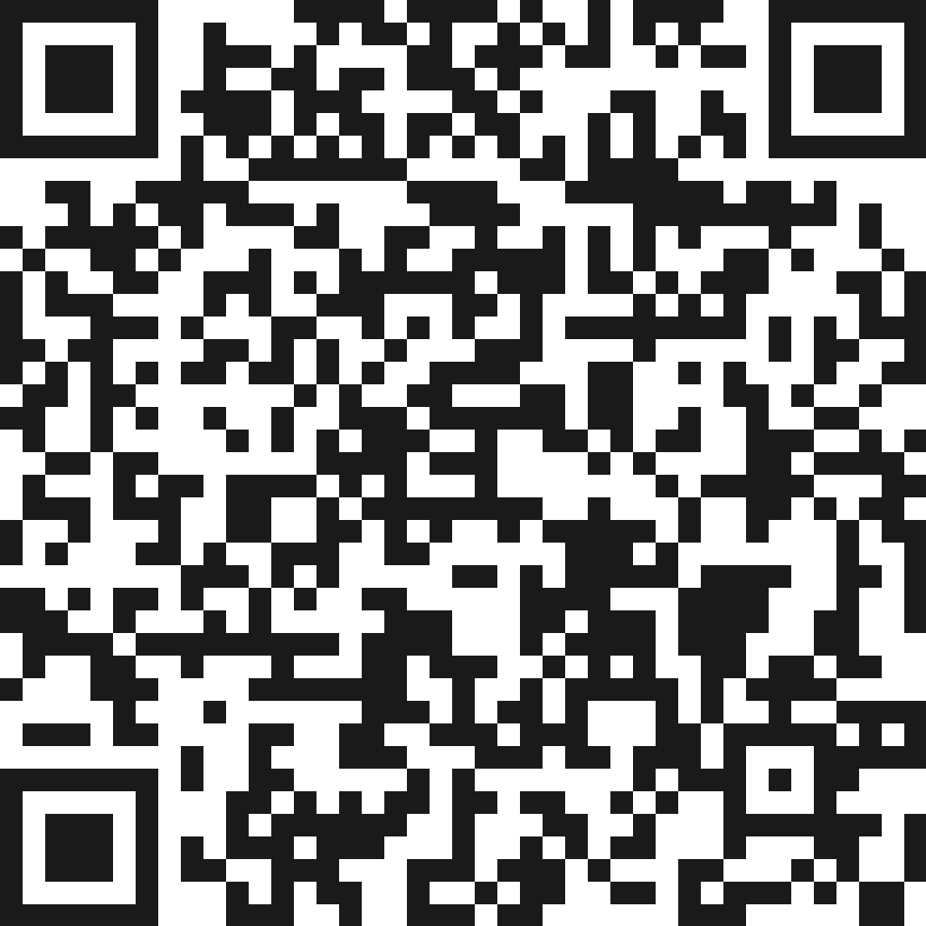
The Jubilant Voices invites the congregation to Fellowship Hour immediately following the service in L.L. White Hall, sponsored in honor of the book signing celebrating Deborah A. Mitchell, author of Love Letters to My Father: 40 Morning Prayers of Trust, Surrender, and Faith. Copies of the book will be available for purchase and signing.

Make Your Pledge to Vote using QR code! As we prepare for our Ballot Education Forum on Sunday, October 18, let us prepare to be a 100% voting congregation! For support contact the church office.
NEXT SUNDAYJoin us for Sunday Worship next week for Holy Communion as Rev. Dr. Jennifer Oliver brings the message and the Holman Choir leads us in song.

CONGREGATIONAL CARE
BEREAVEMENT | The memorial service for Caldwell Durham, father of Carla Pittman and father in law of Alvin Pittman, will be Saturday, October 17 at 11:00am at Holman. Haley Lake, husband of the late Barbara Lake, passed away on September 20. Celebration of Life service will be on Friday October 23. The memorial service for Alfred Green, brother-in-love of Holman member Ann Lloyd, was held on Sept. 25 in Memphis, TN. Let us continue to hold our bereaved families in prayer.
PRAYER LIST | Service people being sent to war in Iran and around the world. Polly McKinney, Raymond Walker, Joan Peters, Mary Johnson, Sharon Edwards Hodgson, Barbara Rosenbaum, Apryl Hall, Audrae Broadnaux, Barbara Williams, Brenda Martin, Carolyn Moultrie, Eretha Minor, Frances Grady, Freddie Muse, Jr., Garth Morgan, Gloria Smith, Gweneth Alexander, Irving Norwood, Sr., Jason Rabb, Jo C. Reed, Joyce Lewis, Juanita Cannon, Kamille Linton, Larry Johnson, Larry Turner, Maritza Brown, Meredith Barrett, Ovis Massey, Paul Madison, Phyllis Stephenson, Sylvia Carter, Dr. Zan Holmes, Rob Durden, Ruth A. Smith, Staci Williams, Ted Davis, Toni Edwards, Dr. Quinton James, Dr. Ronald St. Hill, Edwena Weathersby & The Wiley Family, The Batiste Family, The Cincore Family, The Douglas Family, The Henley Family, The Hobson Family, The Luke Family, The Newsom Family, The Spearman Family. The Gray Family. The Jones Family, The Bordenave-Jenkins Family, The Thomas Family, The Reynolds Family, The Williams Family, The Farris Family, The Blannon Family, The Pittman Family


www.holmanumc.com/calendar

SUNDAY, SEP 27  Holman Choir: Rehearsal  9–10:30am | Every Sunday  Holman UMC Music Room  Adult Sunday School: Class  9:30–10:30am | Every Sunday  Online  Children's Church/Sunday School: Gathering  9:30–10:30am | Every Sunday  Holman Education Building - Room 7  Sunday Worship  11am–12:15pm | Every Sunday  Holman United Methodist Church  NSBE Jr. SoCal  1pm–4:30pm |  Holman United Methodist Church Education Building  THURSDAY, OCT 1  Thursday Bible Study: (Phone)  1–2pm | Every Thursday  Stewardship Committee: Monthly Meeting  6–7pm | The first Thursday of every month  Online  FRIDAY, OCT 2  - Friday Morning Prayer Group: Prayer & Communion Service (Phone)  7:30–8:30am | Every Friday  SATURDAY, OCT 3  - AKA Sorority  10am–2pm  Holman UMC | SUNDAY, OCT 4  Holman Choir: Rehearsal  9–10:30am | Every Sunday  Holman UMC Music Room  Adult Sunday School: Class  9:30–10:30am | Every Sunday  Online  Children's Church/Sunday School: Gathering  9:30–10:30am | Every Sunday  Holman Education Building - Room 7  Sunday Worship :: 11:00 am  11am–12:15pm | Every Sunday  Holman United Methodist Church  ICYOLA Annual Concert  4–6pm  Holman UMC  Mark Your Calendars!  THURSDAY, OCT 8  StoreHouse Ministry Food Distribution Day  10am–1pm | The 2nd and 4th Thursday of every month  Holman UMC  Thursday Bible Study: (Phone)  1–2pm | Every Thursday  UWFaith Leadership Meeting (Zoom)  7–8:15pm | The second Thursday of every month  Holman UMC  FRIDAY, OCT 9  Friday Morning Prayer Group: Prayer & Communion Service (Phone)  7:30–8:30am | Every Friday

